Snow River Scheme

16 Dams

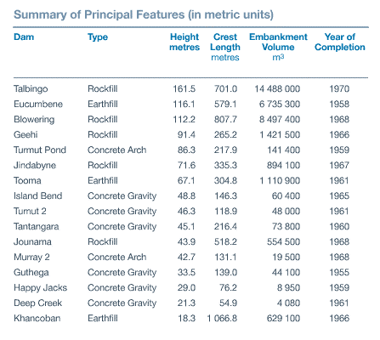

These 9 power stations have 33 turbines with a total generating capacity of 3950 megawatts (MW) and produce on average, 4500 gigawatt-hours of clean renewable electricity each year, to meet peak power demand.

Each year the Snowy Scheme produces on average 4500 gigawatt hours of clean, renewable, hydro electricity, or around 32% of all renewable energy on the mainland National Electricity Market.

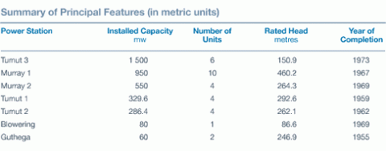

Tunnels

The Snowy Mountains Scheme consists of 145 km of inter-connected tunnels and pipelines and 80 km of aqueducts.

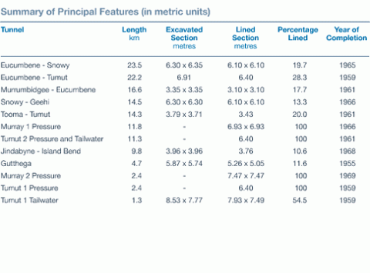

Pumping Stations

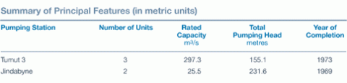

Lake Levels

|  |  |
| --- | --- |
|  | 480 000 mega litres |

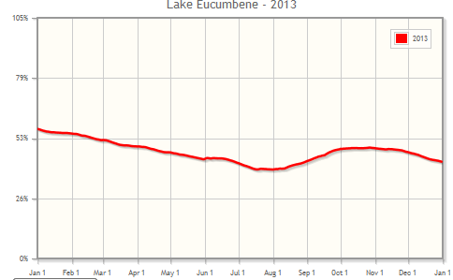

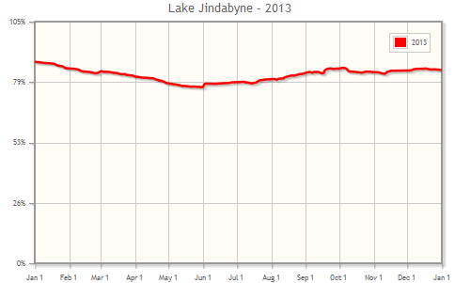

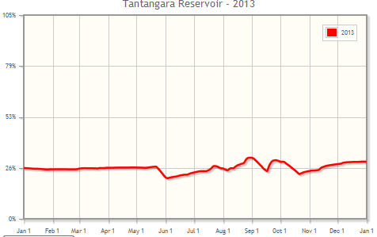

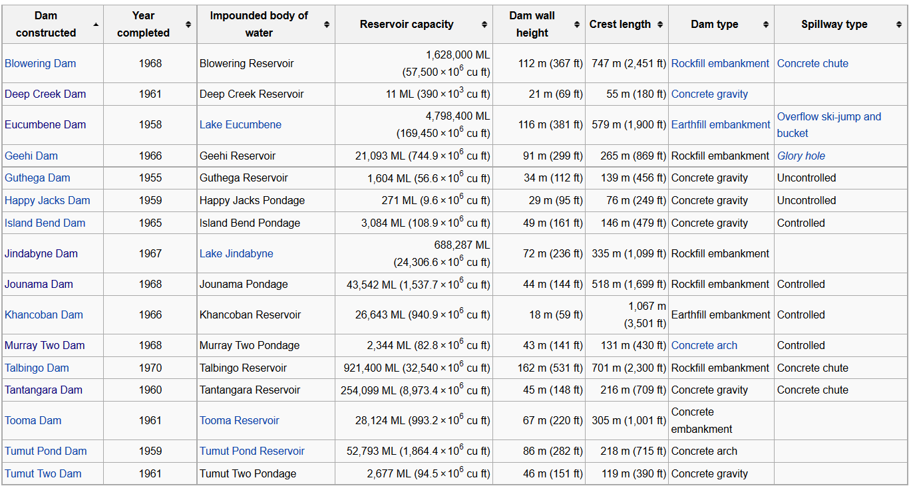

Snowy Scheme inflows for 2012–13 were 2,188GL WATER INFLOW

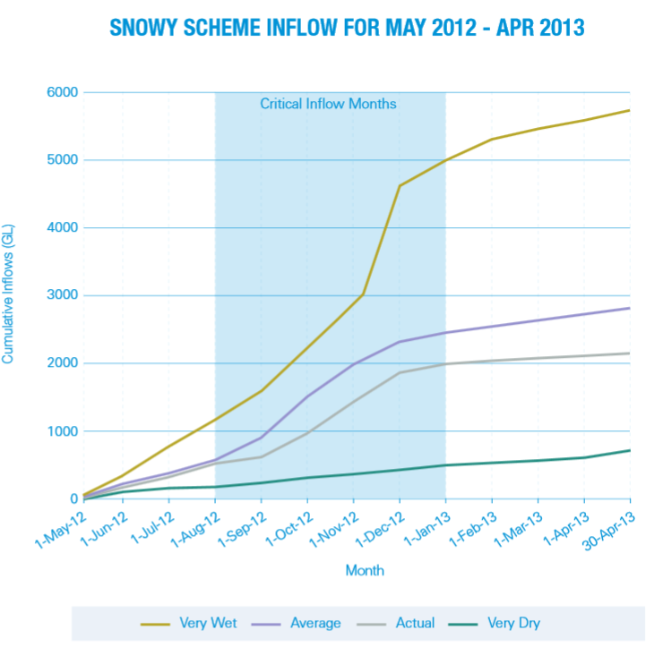

Rainfall

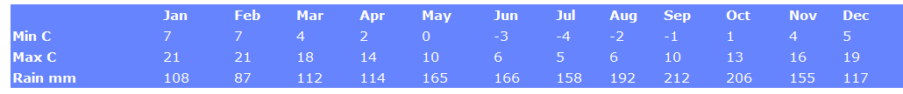

<http://www.atn.com.au/nsw/south/climat-b.htm>

